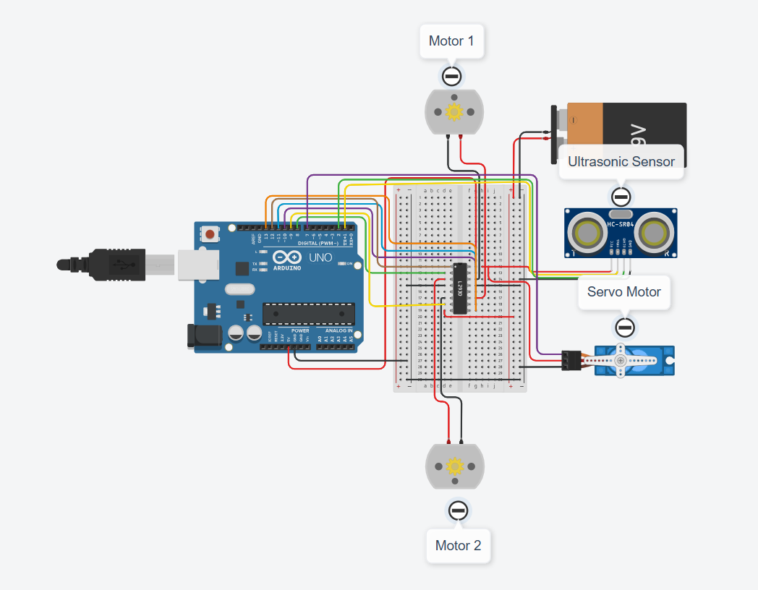

Figure 1: Obstacle Avoidance Robot

// --- Obstacle Avoidance Robot Code – Part 01 ---
// L298N Motor Control
const int enA = 9; // Left Motor Speed
const int in1 = 5;
const int in2 = 6;
const int in3 = 7;
const int in4 = 8;
const int enB = 10; // Right Motor Speed

const int servoPin = 11;

// Ultrasonic Sensor
const int trigPin = 12;
const int echoPin = 13;

int speed = 150;
int threshold = 25; // Stop distance in cm
Servo neckServo;

void setup() {
pinMode(enA, OUTPUT);
pinMode(in1, OUTPUT);
pinMode(in2, OUTPUT);
pinMode(in3, OUTPUT);
pinMode(in4, OUTPUT);
pinMode(enB, OUTPUT);

pinMode(trigPin, OUTPUT);
pinMode(echoPin, INPUT);

neckServo.attach(servoPin);
neckServo.write(90); // Look forward

analogWrite(enA, speed);
analogWrite(enB, speed);
}

Expt No:  05 | OBSTACLE AVOIDANCE ROBOT
Date:
/ /2025

AIM:
To construct and program a 2WD autonomous robot that uses an ultrasonic sensor, mounted on a servo motor, to detect and navigate around obstacles in its path.

APPARATUS REQUIRED:
- Microcontroller: Arduino UNO R3,
- Chassis: 2WD Robot Chassis with 2 DC Motors,
- Motor Driver: L298N Motor Driver Module,
- Sensor: Ultrasonic Distance Sensor (HC-SR04),
- Actuator: Standard Servo Motor (SG90) (for sensor "neck"),
- Power: Battery Pack (e.g., 9V or 7.4V Li-Ion),
- Software: Arduino IDE,
- Components: Jumper Wires, Mini Breadboard.

THEORY:
The robot operates on a "sense-think-act" loop. Its primary state is to move forward. The HC-SR04 sensor, mounted on the servo, continuously "looks" forward to measure the distance to any objects. If the measured distance falls below a threshold (e.g., 25 cm), the robot's state changes to "avoidance." It stops, uses the servo to look left and right, and compares the distances in both directions. It then turns in the direction with more free space before returning to its "move forward" state.

PROCEDURE:

- Connections:
- L298N IN1 (Left Motor) → Arduino Digital Pin 5,
- L298N IN2 (Left Motor) → Arduino Digital Pin 6,
- L298N IN3 (Right Motor) → Arduino Digital Pin 7,
- L298N IN4 (Right Motor) → Arduino Digital Pin 8,
- L298N ENA (Left Speed) → Arduino PWM Pin 9,
- L298N ENB (Right Speed) → Arduino PWM Pin 10,
- Servo Signal (Yellow) → Arduino PWM Pin 11,
- HC-SR04 Trig → Arduino Digital Pin 12,
- HC-SR04 Echo → Arduino Digital Pin 13,
- Connect Motors to L298N OUT1/OUT2 (Left) and OUT3/OUT4 (Right),
- Connect L298N +12V to Battery (+),
- Connect L298N GND to Battery (-) AND Arduino GND (Common Ground),
- Connect Servo VCC and HC-SR04 VCC to Arduino 5V,
- Connect Servo GND and HC-SR04 GND to Arduino GND.

- Code: Upload the following sketch to the Arduino.

- Observation: Place the robot on a clear floor and power it on. It should move forward. Place an obstacle (like your hand or a book) in its path. Observe the robot stopping, turning its servo "neck" to scan left and right, and then turning in the direction with the most open space before proceeding.

// --- Obstacle Avoidance Robot Code – Part 02 ---
void loop() {
int distance = readDistance();

// Is there an obstacle?
if (distance <= threshold) {
// Obstacle detected
moveStop();
lookAndDecide();
} else {
// No obstacle, move forward
moveForward();
}
}

// --- Navigation Functions ---
void lookAndDecide() {
neckServo.write(170); // Look left
delay(500);
int leftDist = readDistance();

neckServo.write(10); // Look right
delay(5D0);
int rightDist = readDistance();

neckServo.write(90); // Look forward again
delay(200);

// Decide which way is clearer
if (leftDist > rightDist) {
turnLeft();
} else {
turnRight();
}

// Move for a short time to clear the obstacle
delay(400);
}

int readDistance() {
long duration;
digitalWrite(trigPin, LOW);
delayMicroseconds(2);
digitalWrite(trigPin, HIGH);
delayMicroseconds(10);
digitalWrite(trigPin, LOW);
duration = pulseIn(echoPin, HIGH);
return (duration * 0.034 / 2.0);
}

// --- Motor Control Functions ---
void moveForward() {
digitalWrite(in1, HIGH); digitalWrite(in2, LOW);
digitalWrite(in3, HIGH); digitalWrite(in4, LOW);
}
void moveStop() {
digitalWrite(in1, LOW); digitalWrite(in2, LOW);
digitalWrite(in3, LOW); digitalWrite(in4, LOW);
}
void turnLeft() {
digitalWrite(in1, LOW); digitalWrite(in2, HIGH);
digitalWrite(in3, HIGH); digitalWrite(in4, LOW);
}
void turnRight() {
digitalWrite(in1, HIGH); digitalWrite(in2, LOW);
digitalWrite(in3, LOW); digitalWrite(in4, HIGH);
}

RESULT AND OBSERVATION:
The autonomous obstacle-avoiding robot was successfully implemented. The experiment demonstrated the integration of ultrasonic sensing for environmental perception and a state-based control logic ("sense-think-act") to achieve autonomous navigation and obstacle avoidance.

